It’s finally here!

Lost in War
The Brave Life and Mysterious Death of a Canadian Airman.

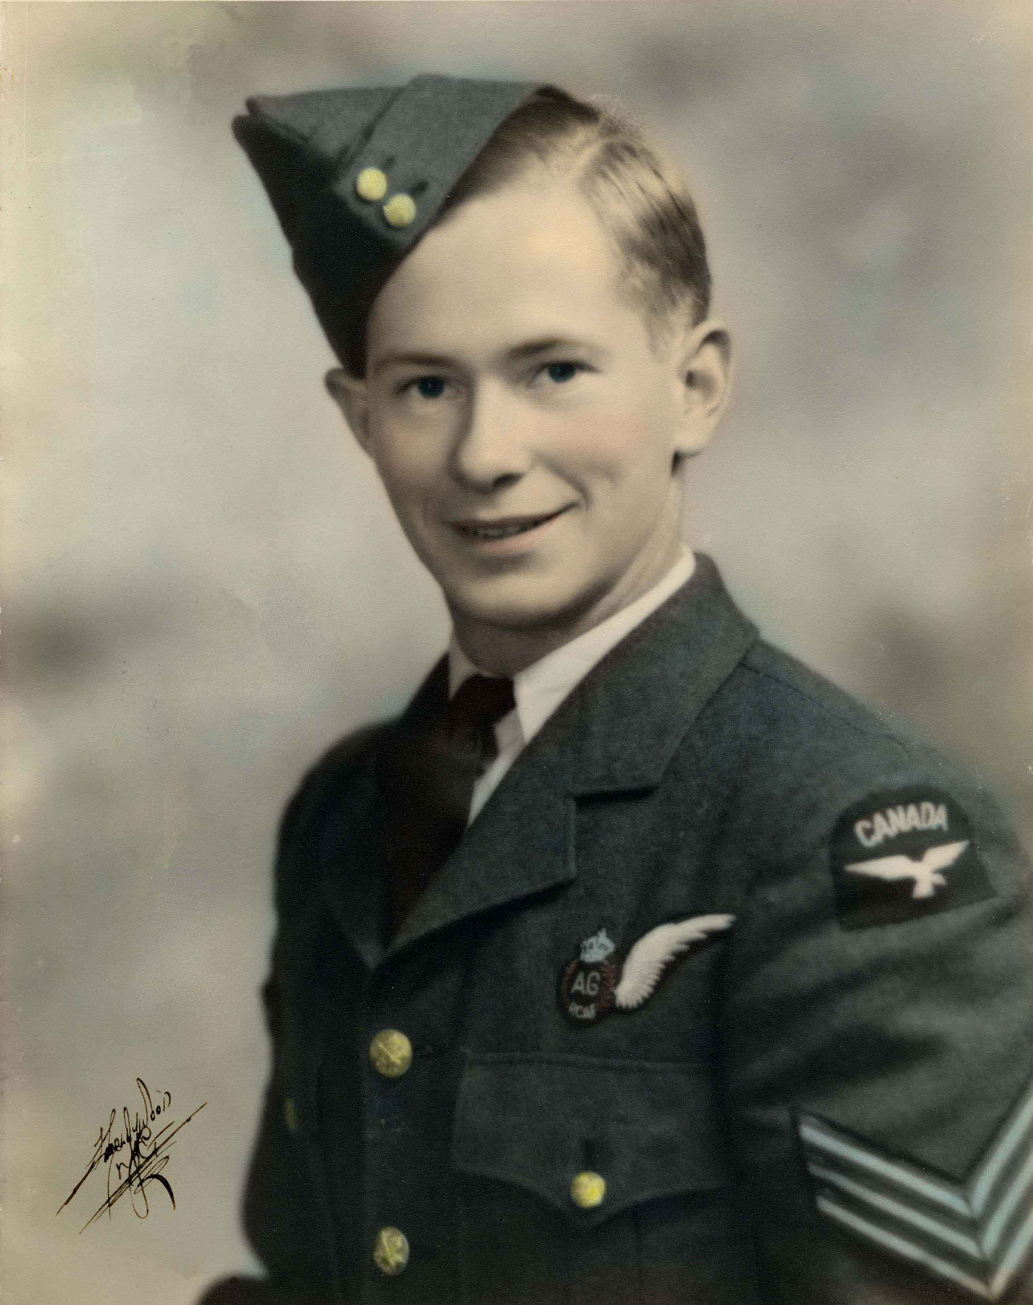
This is the story of Hinrik Guttormson, a young Icelandic-Canadian boy who fought and died over the skies of Europe during WWII.

More than four years of research, family interviews and dogged detective work

have produced this non-fiction book, a labour of love for author James Watt. This true account of the life of his first cousin, Hinrik Guttormson, a twenty year old Air Gunner killed over Germany in March of 1945, is a combination World War II military reference and touching social history.

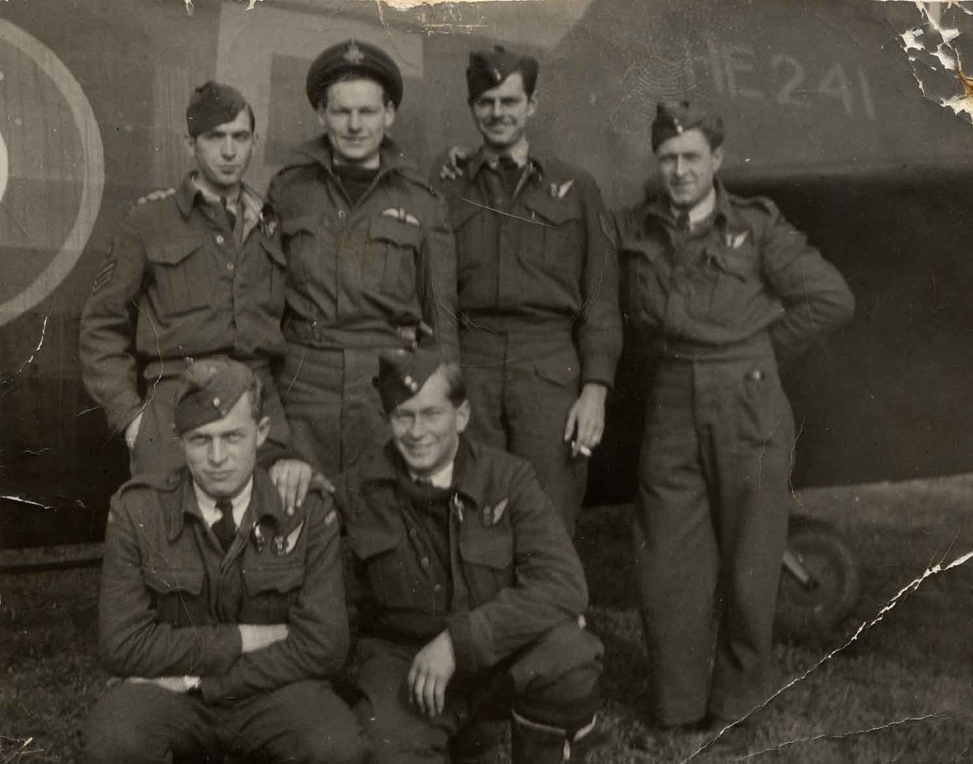
Born and raised in Poplar Park, Manitoba, Hinrik was not an extraordinary young man by most counts. But Hinrik made an impact that has lasted. In 1944, clad in his Royal Canadian Air Force uniform, Hinrik impressed upon a young Jim Watt the idea that heroes wore blue. Hinrik’s childhood, his motivations for joining the fight overseas, his training and his friendships forged here in Canada before shipping off are examined through the use of original letters written home. His experiences are shared in his own authentic voice. The result is more than a family history. In describing the details of Hinrik’s progress from the farm at Poplar Park to the arena of war in Europe, Watt has created a sense of the extraordinary times in which Hinrik lived, and the unique conditions that encouraged so many young men like him to travel far from home to protect their country and civilization. For Hinrik’s journey, as exemplary as it was, was by no means unique. Variations on the same story of valour, followed by destruction and the aching grief of those left behind, played out in large and small communities across the country and much of the world. Thousands of young men died in service, and were mourned by their families and their nations. Their loss and its aftermath suggests that the greatness of humankind should not be measured against our ability to go to war, but rather our ability to recognize and remember the human costs of war.

While of interest to a wide variety of people, including educators, this book will appeal to many Canadian families who have lost a loved one in service to their country. Looking beyond the World War Two experience, all Canadians will be able to relate to the experiences of young Hinrik and his journeys across the sky.

Author Biography
Jim Watt graduated from the University of Toronto with an Honours history degree in 1962 and then went on to McMaster University where he completed his MA in 1965. He then dedicated the next thirty-three years to teaching at the Secondary School level. Popular and enthusiastic, Watt has not been able to leave the world of teaching behind in retirement. He once again shares his passion for telling the stories of the past with this, his first book. Watt presently researches and writes for the Ontario Provincial Police Museum as well as the Orillia Local Architectural Advisory Conservancy. He has published articles in the Canadian Historical Review, Ontario History, and the Ontario Provincial Police Review. Hinrik Guttormson was Jim’s first cousin.

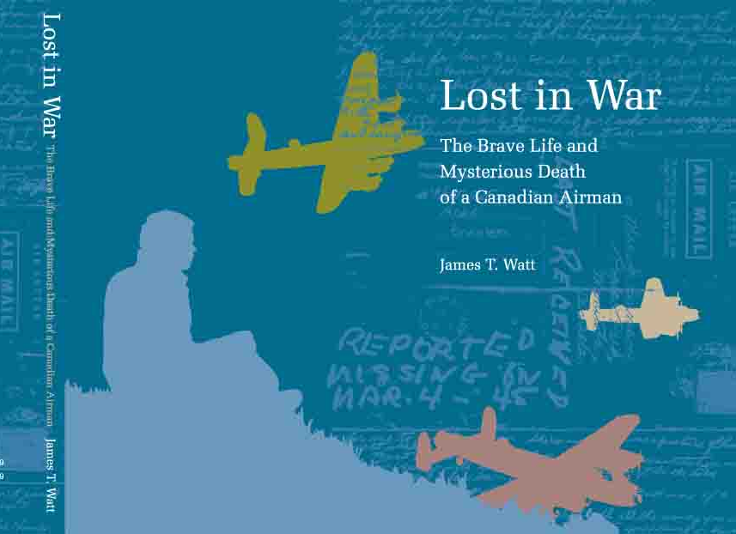
To order your copy, please contact:

In writing:

Troutspawn Publishing
14 Tecumseth St.
Orillia, ON L3V 1X8

Email requests to: jnrwatt@rogers.com

